Wu Zhi-qiang, Ph.D candidate, His main researches include virtual geographic environment, 3D Visualization and Battlefield Visualization.
E-mail: herowzq@126.com or herowzq@163.com

RESEARCH ON VISION VARIABLE OF VIRTUAL TERRAIN ENVIRONMENT
Wu Zhi-qiang, Zhao Dong-ming
(Institute of Surveying and Mapping, Information Engineering University, Zhengzhou,Henan, 450052)

AbstractWith the further development of Virtual Reality Technique, its application in Cartology has got a fast advance. As a result, the Virtual Terrain Environment has become an important approach in the cognition of geo-spatial environment. As a graphical language of geo-spatial information expression, the design of 3-D map symbol system has a vital impact on the efficiency and effect of geo-spatial information transmission. Because the 3-D vision variables are basic elements of the design of 3-D map symbols, this paper firstly makes an analysis of the characteristics of virtual terrain environment and a comparison of 2-D and 3-D expression methods, then proposes the 3-D vision variables of virtual terrain environment, which includes a) the basic variables, such as shape, material, texture, attitude and so on, b) kinetic variables, such as duration time, frame velocity, sequence, and c) environment variables, such as view point, light, shade, fog, etc. Finally the applications of vision variables are discussed.
Keywords virtual terrain environment; 3-D map; map symbol; vision variables

1. Introduction
As the carrier of spatial information, the function of maps is determined by the entire representation of symbols to a great extent. The map symbols are map’s figure language and the media with which the objective world, cartographer and map users are connected and map information is conveyed. The two basic functions of map symbols are as follows. Firstly, they tell the characteristics of the category, quantity and quality of objects. Secondly, they can be used to determine the distribution of the spatial locations and phenomena of objects. Map symbols of high quality are necessary premise by which the map content can be enriched and the maps’ readability can be enhanced [1].
The vision variables are elements that constitute the map symbols. The basic figures, colours that can cause vision varying on maps are called vision variables, or figure variables. In 1967 a Frenchman, J.Bertin, after his study of more than 20 years, firstly proposed the vision variables, which are shape, orientation, size, brightness, density and colour. The proposition of vision variables play an important role in improving the composition rules using 2-D figure symbols and enhancing the representation of maps.
In recent years, with the development of virtual reality technique as well as its further application in cartography, the virtual terrain environment has been one important means for people's cognition of geo-space. In fact, the virtual terrain environment is the visual representation of geo-spatial information based on digital maps within 3-D graph environment. There is an essential difference between the virtual terrain environment and traditional 2-D representation. The research of the principles of the visual design of the virtual terrain environment has been one important aspect of improving information representation and transmission efficiency of the virtual terrain environment.
The 3-D vision variables are basics of the design of the virtual terrain environment. The extension of the space dimension of representation, the dynamic and interactivity in applications of virtual reality and 3-D moving picture, cause the development of vision variables of the virtual terrain environment and the difference from the state description of traditional 2-D static map symbols. In this paper the characteristics and technical principle of the implementation of the virtual terrain environment are analyzed, and it is proposed that the 3-D vision variables should include three parts: basic variables, dynamic variables and environment variables, and then the functions of different variables in the design of virtual terrain environment are discussed.

2．Characteristics of the Virtual terrain environment
The application of Virtual Reality technology in cartography produces the multi-dimensional space of virtual terrain, or virtual terrain environment. The virtual terrain environment is based on geo-spatial information which is characterized by spatial location, spatial attributes, spatial relation and time. The virtual terrain environment generated by computers has the following important features:
(1)Multi-dimensional. The virtual terrain environment implements the abstract reflection of the real world based on geo-spatial information through modelling the objective world, which means that multidimensional is one essential property of the virtual terrain environment.
(2) Real-time dynamic. The time property of geo-spatial information requires the dynamic representation of the virtual terrain environment.
(3) Real-time Interactivity. As one means of people's cognition of the real world, interactivity is one basic requirement for the virtual terrain environment and multiple interactive methods are provided.
(4) Perspective projection. The generation of the virtual terrain environment is always based on 3-D projection, which often causes the deformation that the object seems larger at close distance and smaller far off.
From the above-mentioned features, the difference between the virtual terrain environment and the traditional 2-D representation method includes:
(1) Symbol system. 3-D cartography symbols are used to represent geo-spatial information, while the traditional 2-D representation applies 2-D cartography symbols.
(2) Space dimensions. The virtual terrain environment makes symbol configuration within 3-D space and the symbol has six freedoms. The traditional 2-D representation works within 2-D space and the 3-D information is projected onto 2-D space.
(3) Display technique. The display method of 3-D graphics is totally different from that of 2-D graphics. The latter makes a direct draw of the graphics to be displayed in display memory and then displays the graphics on the screen using page exchange method. The former requires a process of world coordinate system transformations, camera coordinate system transformations, perspective transforms, rendering and colouring, viewpoint switch, and finally output the 3-D graphics, which requires a real-time drawing of at least 15 frames per second.
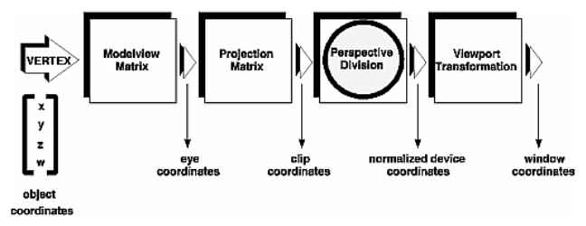
(4) Geometrical fundamentals. The virtual terrain environment applies the perspective projection method which causes the phenomenon that the screen object seems larger at close distance and smaller far off, and the deformations on X-axes, Y-axes and Z-axes and uncertainties are called line-of-sight uncertainty and projection uncertainty which are the difficulties in symbol orientation and attitude cognition. The traditional 2-D representation method applies the top view parallel projection which causes the uncertainty in height information representation due to the uncertainties of the line of sight and projection. Fig.2 shows the difference.
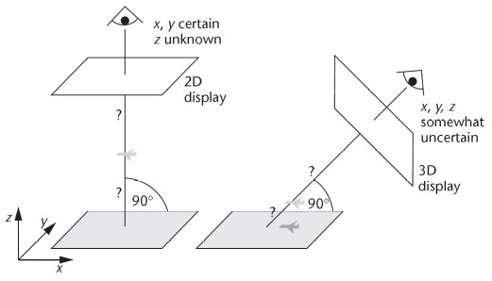
Figure 2-1 Line of sight ambiguity in 2D and 3Ddisplay^{[4]}
^{[4]}

3．3-D Vision Variables
The features of the virtual terrain environment determines that the 2-D vision variables cannot satisfy the requirements of the design of 3-D cartography symbols. The vision variables for the design of 3-D cartography symbols within the virtual terrain environment include basic variables, dynamic variables and environment variables.

3.1 Basic variables
Similar to the 2-D symbol vision variables, the basic variables are principally graphic elements of symbols, but they have a different meaning in 3-D environment. The basic variables include location, shape, material, texture, attitude and relative size.
(1) Location. Location means the locating point or line of 3-D symbol within the virtual terrain environment. The factor of changing locations in graphic display enables the location to be one basic variable. Fig.3-1 shows the symbols of changeable locations within a region. The notation locations vary, and symbol location changes when dealing the conflict of symbol locations. The location variable is always used to represent the spatial distribution and relative connections.
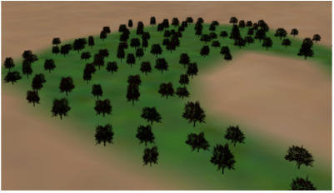
Figure 3-1 Location of tree

(2) Shape. Shape is the most important composition element of 3-D symbols. For 3-D symbols, especially when the surface entity model is used as a symbol, the shape variable is actually the point entity symbol itself. The design of these symbols is distinguished by their real appearance. The difference of 3-D line and area symbols in shape and profile, such as the line and area, is not the difference between vision variables, but the difference between graphics, as Fig.3-2 shows.
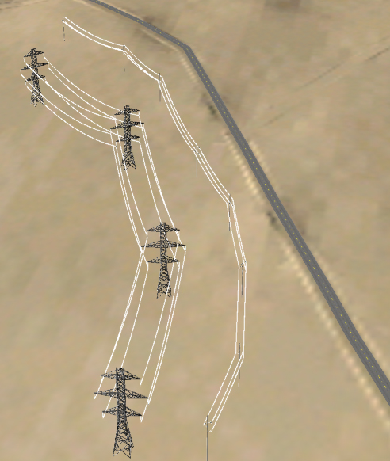
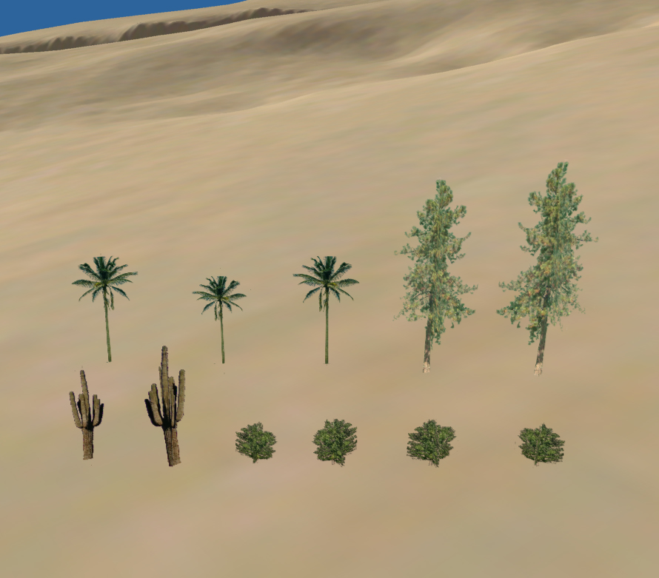
Figure 3-2 Different shape of 3D symbol

(3) Texture. Texture generation has a lot of important applications in the creation of images of 3-D looks. The texture is actually the filling of a spatial polygon surfaces using planar graphics by contrasting the planar graphics and spatial polygons. The relation between the texture and the polygon is represented by texture coordinates. Texture technique includes a lot of applications of texture types, for example, transparent texture, protruding and concaving texture, 3-D texture, etc. The application of texture technique can not only handle the rendering speed, but provides a new means for symbol design. Usually the texture variety is applied to distinguish features of 3-D symbols, such as the quality and class.
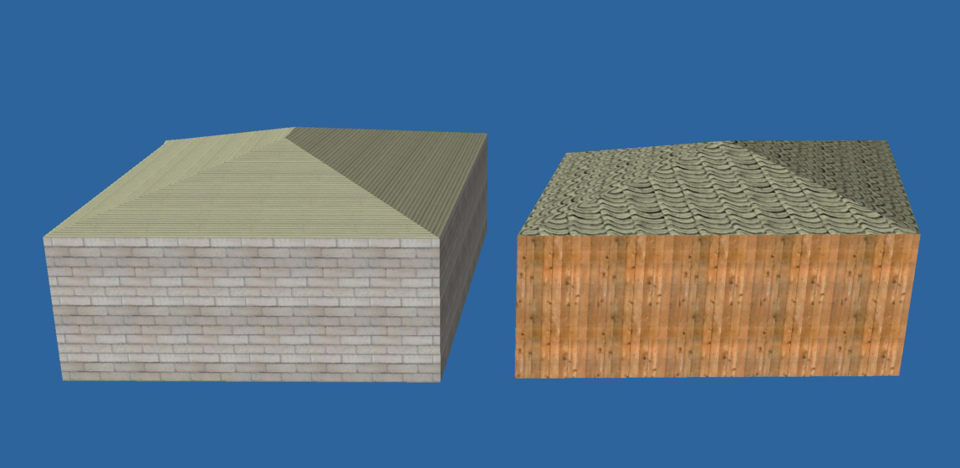
Figure 3-3 Room with different texture

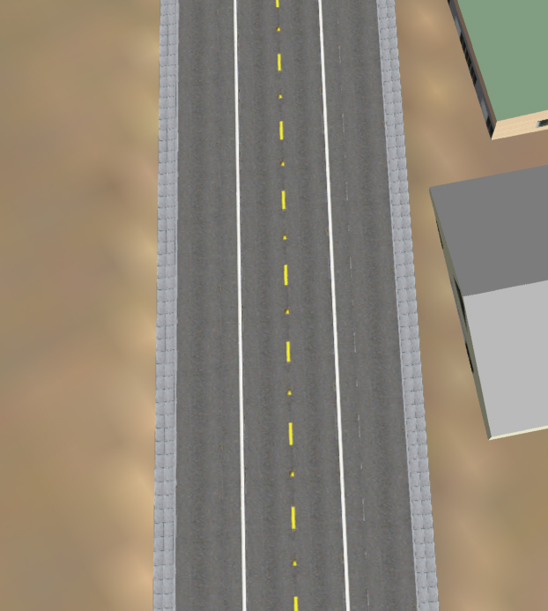
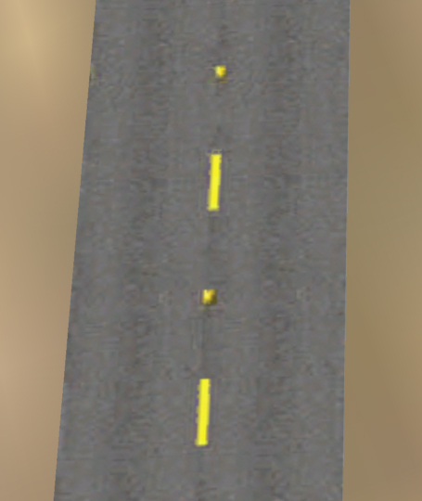
Figure 3-4 Road with different texture

(4) Orientation. The orientation refers to the changes of symbol directions. The symbol orientation within 3-D space has three changes: horizontal, vertical and pitching. Point symbol does not necessarily have orientation change. The orientation change of point and line symbols compose the direction change of the symbols themselves. The orientation of symbols is usually called the dynamic vision variables.
The basic vision variables is a graphic variable concept, while the dynamic vision variable is a time-variable concept, which uses a series of graphic or image symbols to represent the dynamic process, mode, route, duration, varying rate, etc of some spatial phenomenon and thus represent te realistic status and properties of spatial phenomena or objects.
(1) Moment
Also display date. It can be applied in time-related animation and non-time-related animation. For non-time-related animation, moment may refer to the appearance of some behaviour. For time-related animation, moment can refer to the appearing time of some event, and the time has realistic meaning.
(2) Duration. It refers to the time interval between static scenes, which determines the pace of map animation. It is mainly used to represent the continuation of dynamic phenomenon. The greater the duration, the longer of the generation time or continuation is.
(3) Frequency
Frequency refers to the rate of graphics appearance, which is similar to static 'texture' vision variable. It can also be applied in time-related animation and non time-related animation. For example, in non time-related animation, it can use the difference of flashing frequency to indicate the difference in importance; in time-related animations, the frequency of events has realistic time meaning.
(4) Order
Order refers to the precedence of scenes. For time-related animation, time is the actual order. For non time-related animation, time order may not be used to emphasize the relations between specific phenomena.
(5) Rate of Range
Represented as M/D. M refers to Magnitude, which is the extent of scene varying. Big magnitude can produce animations of great jump feeling, and little magnitude can generate smooth animations. D refers to duration.
(6) Synchronization
It refers to the relation between two or more phenomena. Order and synchronization are important factors in consequence representation.
Fig. 3-6 shows the dam construction and reservoir sluicing using dynamic variable, say time variables, in virtual terrain environment.
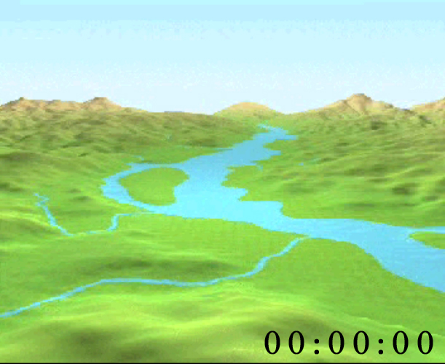
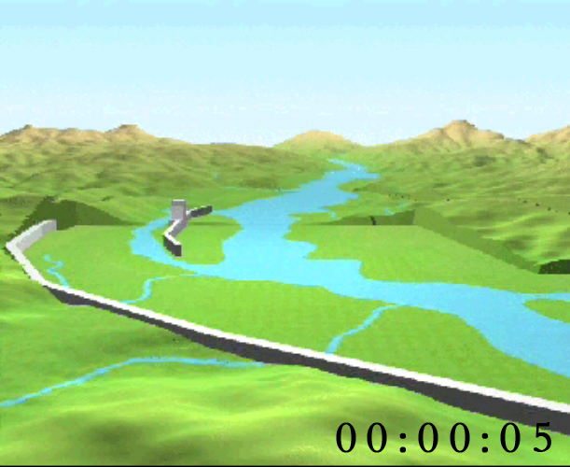
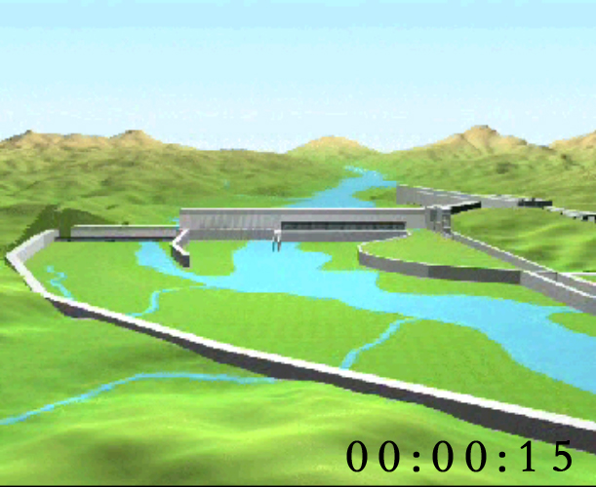
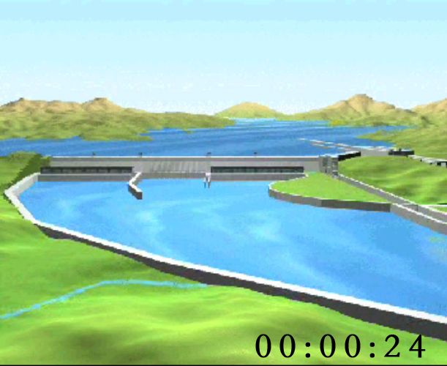

Figure 3-6 dam construction and reservoir sluicing

The dynamic vision variables can be viewed as effective tools in the design of real time dynamic virtual terrain environment, with which uses can control all visualization operations. Of the dynamic vision variables the most important is the duration and order, which have the greatest effect on the description of dynamic features and sometimes can be used to directly describe the spatial data characteristics. For example, the representation of uncertainty using the duration of orderless flash points. The other dynamic vision variables depend more or less on the two variables, for example, display time, frequency and rate, or special application, such as synchronization.

3.3 Environment Variables
The effect of the design and representation of 3-D symbols within virtual terrain environment is not only determined by the above-mentioned basic and dynamic 3-D vision variables, but is also determined by factors including viewpoint location, light, shade, fog, etc. All of the factors, together with the symbols, contribute to the final representation of symbol graphics. This is why they are classed into environment variables.
（1）Viewpoint and View sight
View point and view sight refer to the location and orientation of the camera within the virtual terrain environment. The 2-D maps are top- view and orientation fixed, while the viewpoint and view sight can be adjusted by users at will. Therefore, the change of viewpoint and view sight has a direct effect on the representation of virtual terrain environment. For example, the change of viewpoint and view sight requires real-time rotating of the symbols of bulletin attribute and always towards the viewpoint. The distance of viewpoint also has a direct effect on the size, details and cognition precedence of symbols and different distance form viewpoint of symbols of the same size will have different cognition. The varying of viewpoint and view sight also cause the change in level details of symbols, including the switching of detail symbols of different levels and the varying of single symbol details, for example, the direct representation of rivers, vegetables, roads using textures under high viewpoint and the representation using corresponding level detail symbol under low viewpoint.
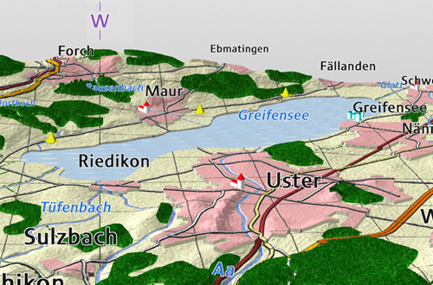
Figure 3-7 Billboard of note^{[10 ]}

(2) Light
The brightness and colour of 3-D symbols within virtual terrain environment are composed under the interaction of light and symbol material. The light within 3-D environment mainly includes the light radiated on object's surface, and is divided into three parts: floodlight, light of diffuse reflection and light of mirror reflection.
The floodlight is isotropic and used to simulate the light that is scattered onto the object from the environment objects. It only causes the change of surface brightness. Light and shade can not be formed only with floodlight, and the surface details can not be distinguished in scene only with floodlight.
The light of diffuse reflection is even in space distribution. The intensity of reflection light is positively proportional to the cosine of the incidence angle of incidence light.
Ideal mirror reflection light is only propagated along reflection line. However, smooth surfaces that we usually see are not ideal reflecting surfaces, only that there is more light along the reflection line. And the amount of light along other directions is concerned with the angle between the direction and the reflection direction.
(3) Shadow
Within virtual terrain environment, shadow may provide the depth hints of entities and enhances the 3-D looks of objects. In the design of tree symbols, the shadow of trees on the ground can be dynamically rendered and thus enhance the third dimension of building symbols.
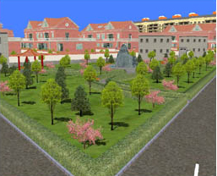
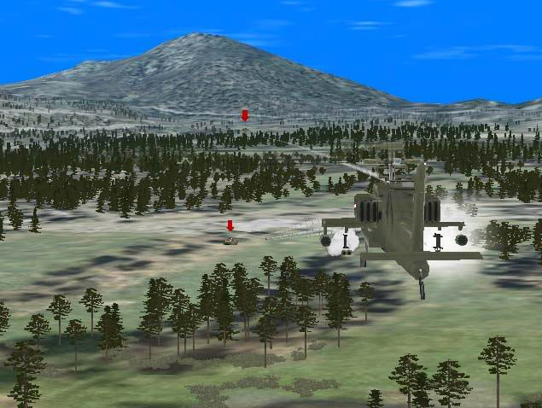
Figure 3-8 Effect of shadow render

(4) Fog
Fog is the simple gas effect that can be added into the 3-D graphic environment. Using fogging the realistic feeling of the virtual terrain environment can be improved and users get aid in determining the distance of symbol locations.
As Fig.3-9 shows, the application of fogging effect makes the symbol far off look more remote and vague, and the symbol at close distance look clear and distinct, which enhance the visual difference between symbols.
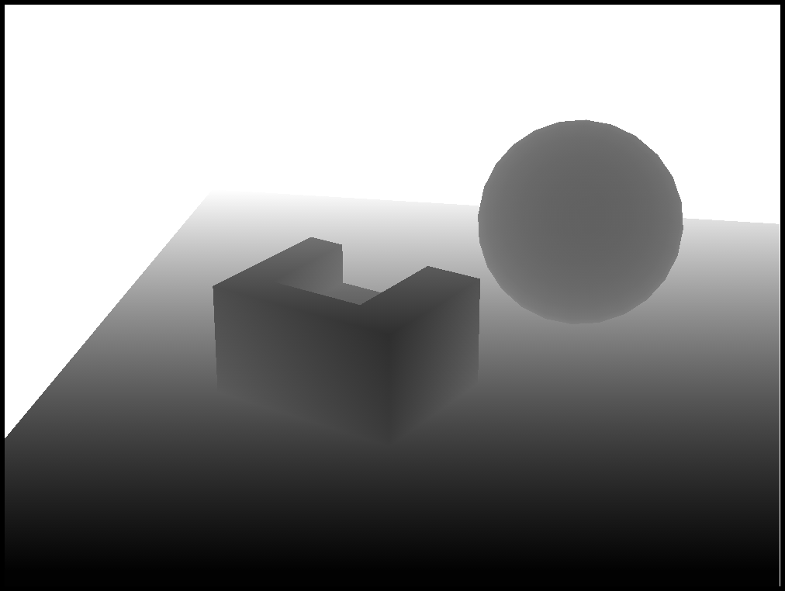

Figure 3-9 Fogging effect

4．Summary
As the foundation of the design of virtual terrain environment, the 3-D vision variables give rise to the emergence of 3-D and multi-dimensional symbolic language representation and cause the representation of 2-D and static geo-spatial information to advance towards 3-D and dynamic virtual environment simulation. The research of 3-D vision variable has a great impact on the design of virtual terrain environment and applications of symbolized virtual terrain environment.
The 3-D vision variables are the basis of the virtual terrain environment, 3-D GIS, visual design of vision simulation. Based on the traditional 2-D symbolic design of vision variable and practices, we make initial research on vision variables of 3-D symbol and hope to give an incentive to the study of this field.

REFERENCES
- Tian Desen, Mapping Theory modern theory of cartgraphic [M] Publishing company of Surveying and Mapping 1991.10.
- Gao Jun. Visualization of Geospace Data[J]. Engineering of Surveying and Mapping，2000，9(3)：1-7.
- Chen Yufen. Vision Variable of Map[J]. Journal of Institute of Surveying and Mapping, 1995，12(2):145-148
- Harvey S. Smallman，Mark St. John，and Heather M. Oonk，Information Availability in 2D and 3D Displays, IEEE Computer Graphics and Applications，2001.1
- Gao Yurong，Zhu Qing. Vision Variable of 3D Model in GIS[J]. Science of Surveying and Mapping，2005，30(3)：41－43
- Xu Zhiyong, AI Tinghua. On Visual Variables of 3D Map Symbol[J]. Geomatics and Information Science of Wuhan University. 2006.6：557－580.
- J.Bertin．Graphics and Graphic Information Process—ing[M]．Berlin：Walter de Gruyter，1981
- Bandrova T． Designing of Symbol System for 3 D City Maps[C]．The 20th International Cartographic Conference，Beijing. 200l
- OpenGL Programming Guide
- Symbolization and Visualization of Topographic 3D-Maps. http://www.ika.ethz.ch/research/research13.html

